RGB Plan v1架構和合併方法

1. RGB Plan v1:

Input shape = (3, 28, 28)

SOMNetwork(

(RGB_preprocess): Sequential(

(0): RGB_Conv2d(weight shape=torch.Size([36, 3]), kernel size=(5, 5))

(1): cReLU(bias = 0.4)

)

(GRAY_preprocess): Sequential(

(0): RBF_Conv2d(weight shape=torch.Size([64, 1, 5, 5]), kernel size=(5, 5))

(1): cReLU(bias = 0.4)

)

(layer1): Sequential(

(0): SFM(filter=(2, 2), alpha=0.9)

)

(layer2): Sequential(

(0): RBF_Conv2d(weight shape=torch.Size([225, 1, 10, 10]), kernel size=(10, 10))

(1): cReLU(bias = 0.1)

(2): SFM(filter=(1, 3), alpha=0.8999999761581421)

(3): RBF_Conv2d(weight shape=torch.Size([625, 1, 15, 15]), kernel size=(15, 15))

(4): cReLU(bias = 0.01)

(5): SFM(filter=(3, 1), alpha=0.9)

(6): RBF_Conv2d(weight shape=torch.Size([1225, 1, 25, 25]), kernel size=(25, 25))

(7): cReLU(bias = 0.01)

)

(fc1): Sequential(

(0): Linear(in_features=1225, out_features=15, bias=True)

)

)

**每層的output shape:**

Input shape = [-1(batch_size), 3, 28, 28]

----------------------------------------------------------------

Layer (type) Output Shape Param #

================================================================

RGB_Conv2d-1 [-1, 36, 6, 6] 0

cReLU-2 [-1, 36, 6, 6] 1

RBF_Conv2d-3 [-1, 64, 6, 6] 1,600

cReLU-4 [-1, 64, 6, 6] 1

SFM-5 [-1, 1, 10, 10] 0

RBF_Conv2d-6 [-1, 225, 1, 1] 22,500

cReLU-7 [-1, 225, 1, 1] 1

SFM-8 [-1, 1, 15, 15] 0

RBF_Conv2d-9 [-1, 625, 1, 1] 140,625

cReLU-10 [-1, 625, 1, 1] 1

SFM-11 [-1, 1, 25, 25] 0

RBF_Conv2d-12 [-1, 1225, 1, 1] 765,625

cReLU-13 [-1, 1225, 1, 1] 1

Linear-14 [-1, 15] 18,390

================================================================

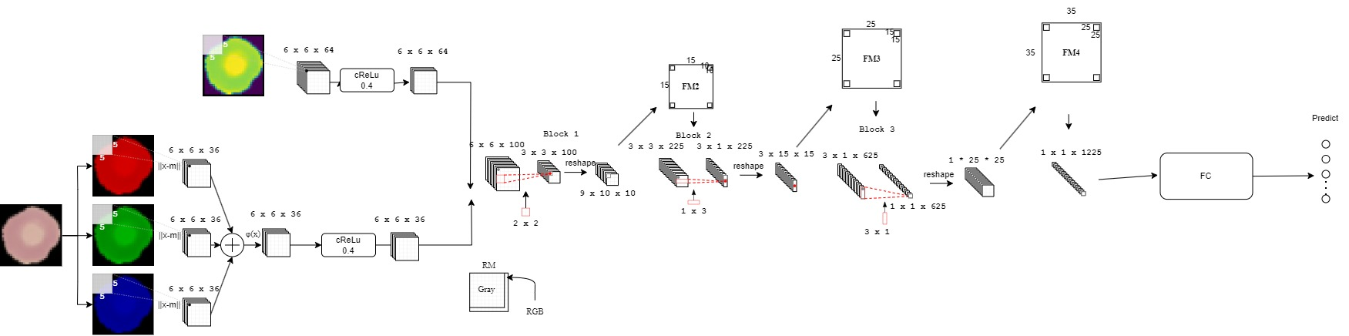架構圖



目前CI 的產生方式是使用之前景豐論文中的方式，但是產生出來的圖片有明顯的錯誤，推測可能是因為Gray 和RGB 的RM在前面有做concat的影響，目前正在研究新的CI生成方法

預測成功的案例:

Correct: green_rectangle

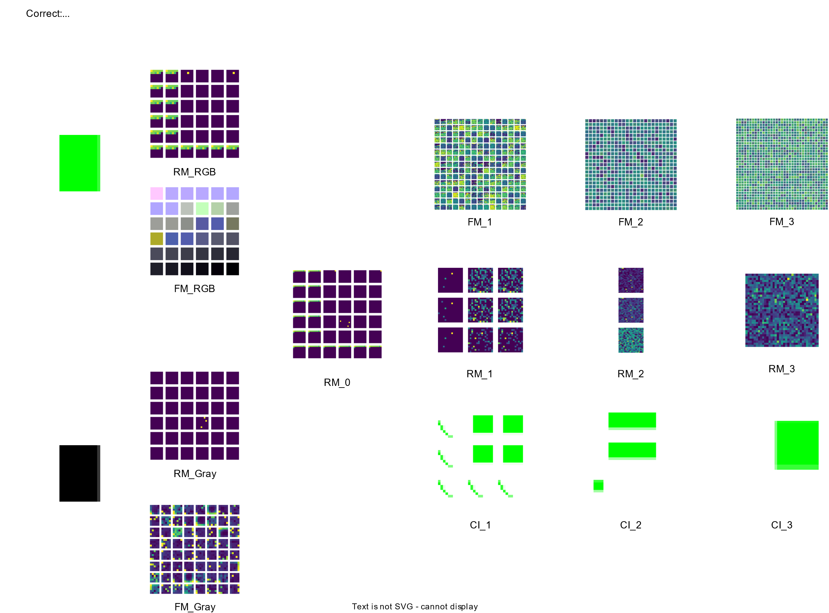

Correct: red_square

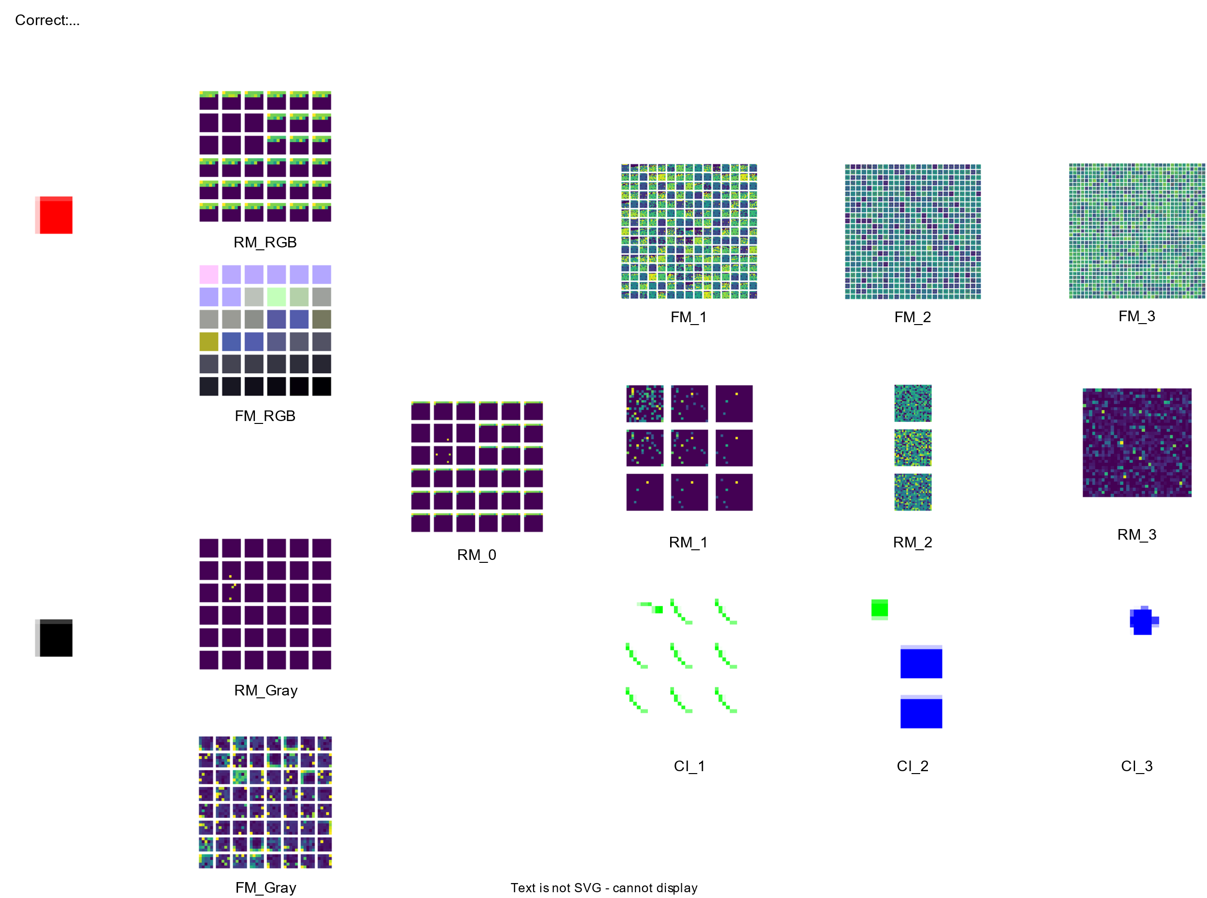

Correct: Blue Circle

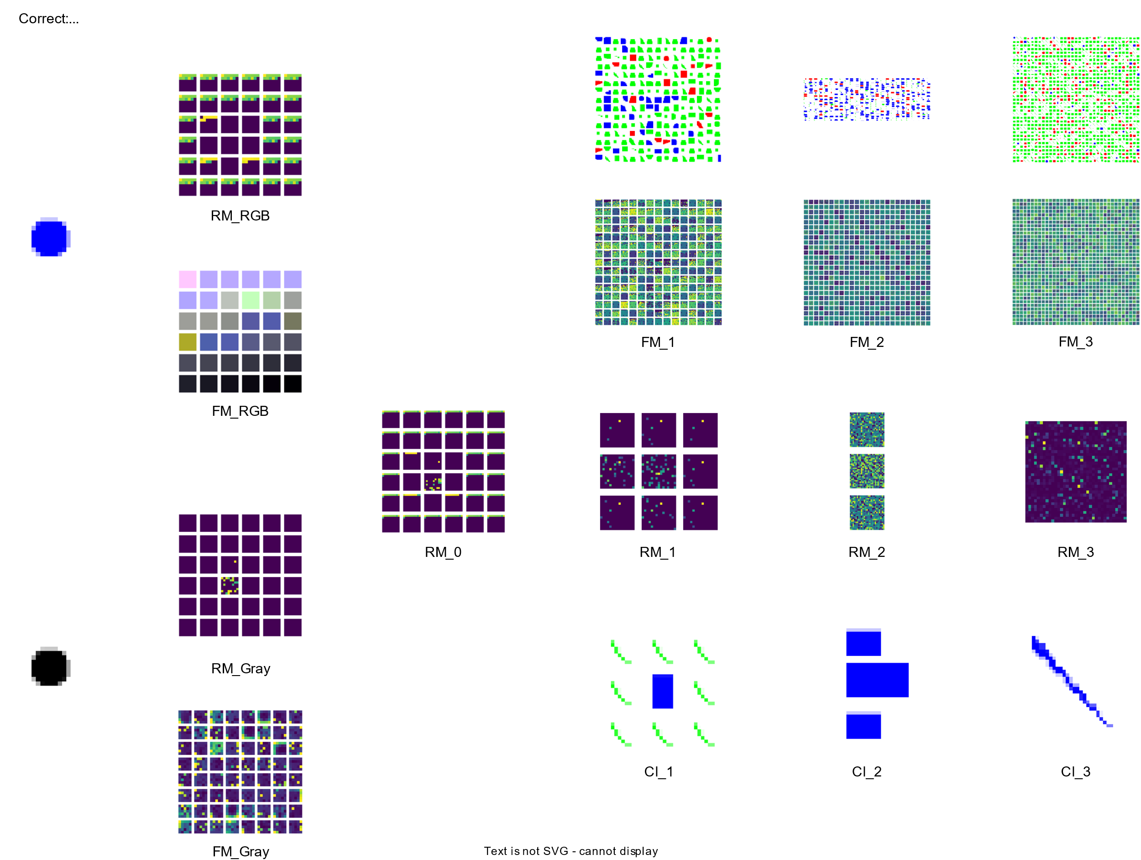

預測失敗的案例:

Truth: blue_ellipse, Predict: blue_triangle

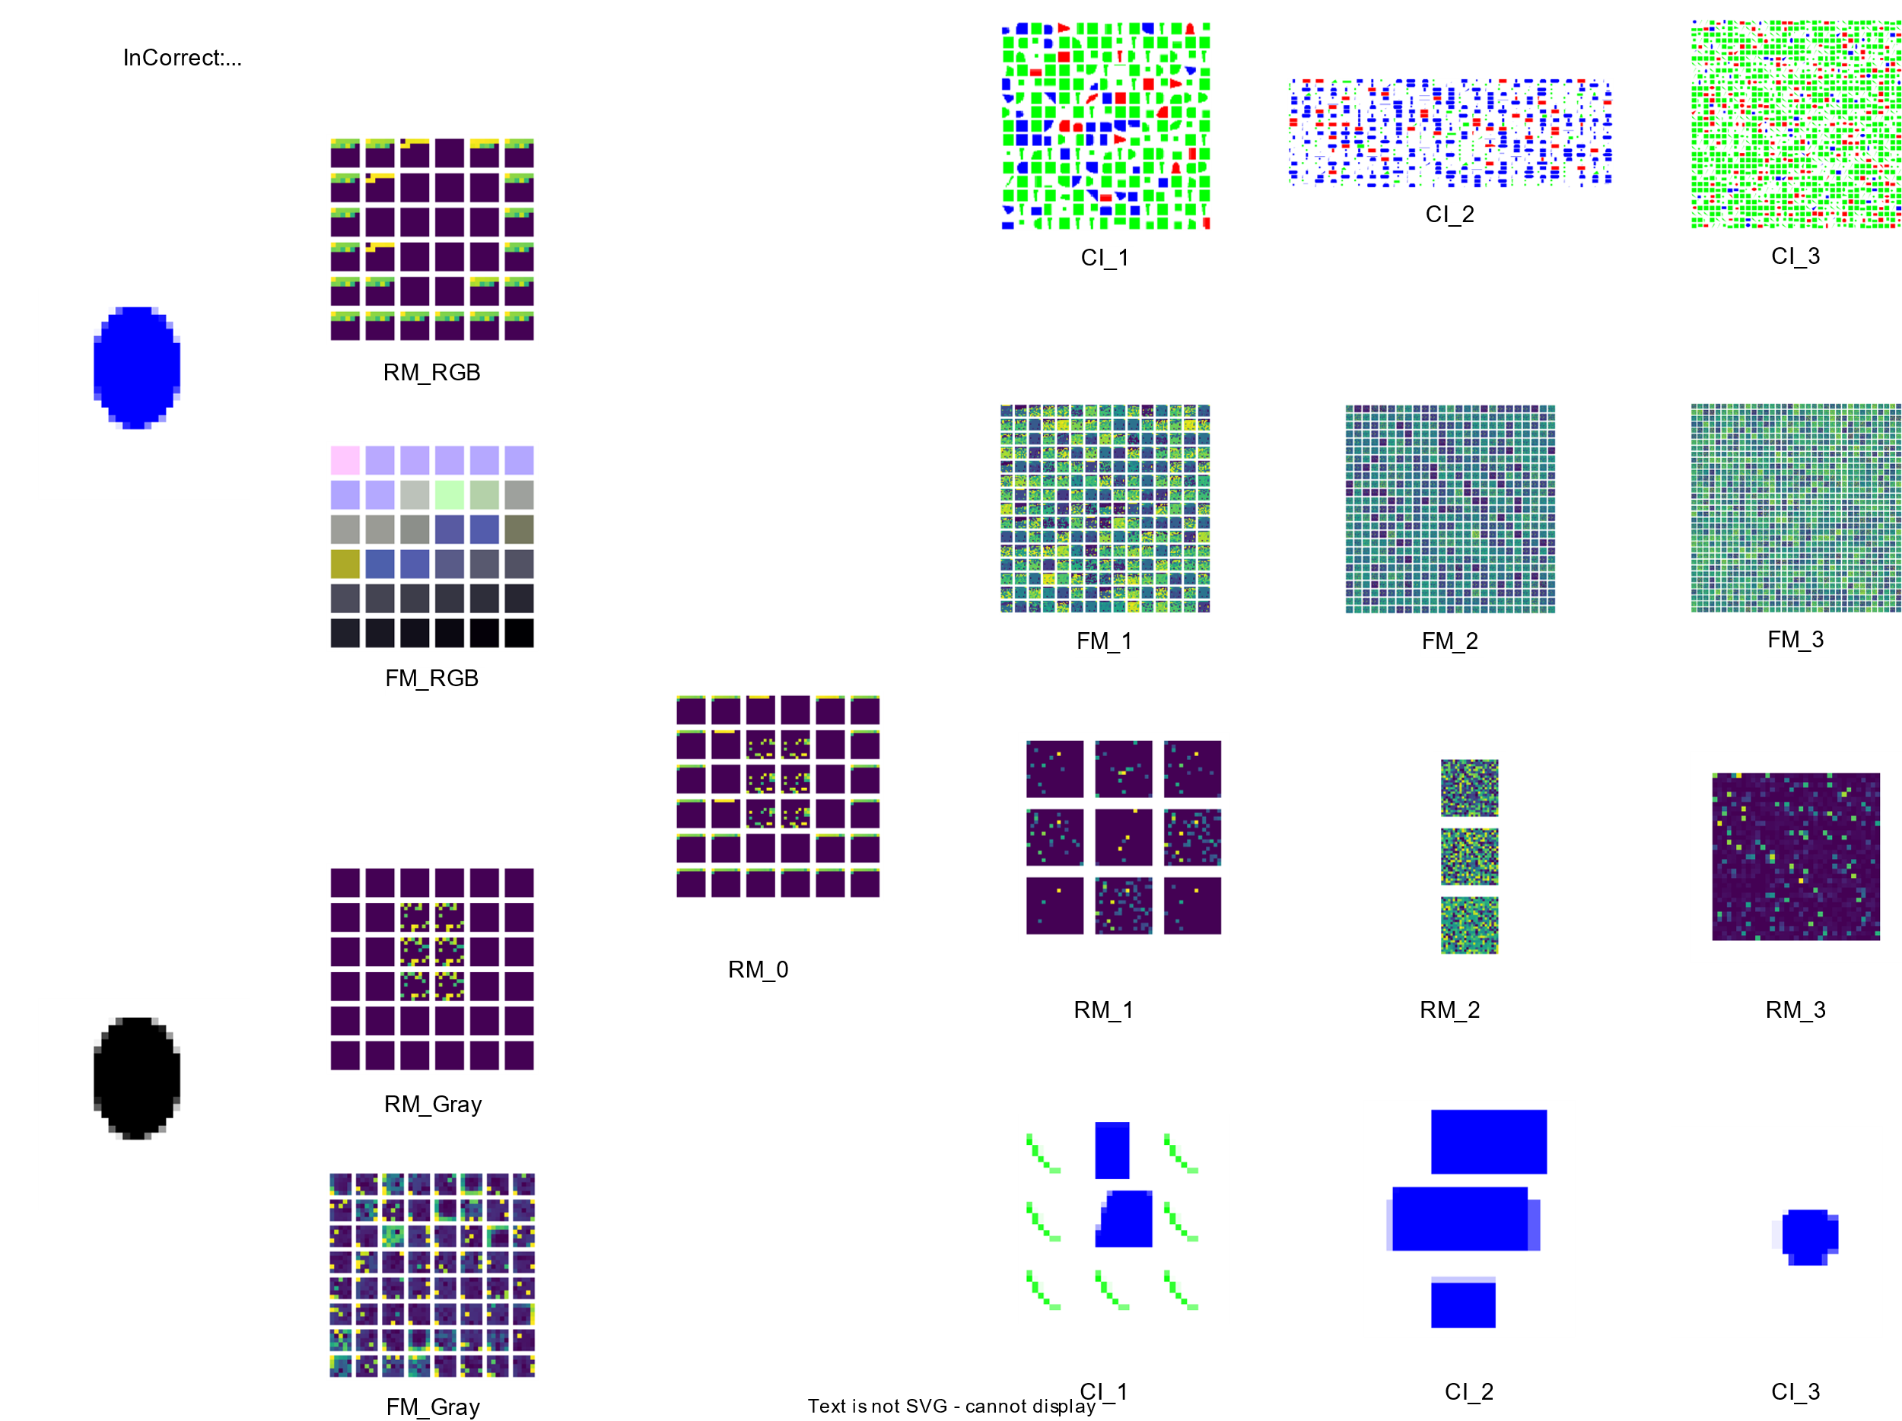

Truth: green_triangle, Predict: green_square

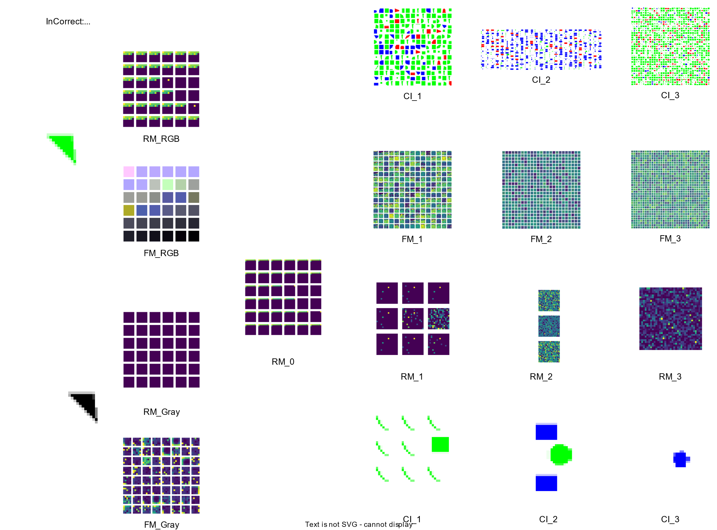

Truth= Red Circle, Predict = Red Square

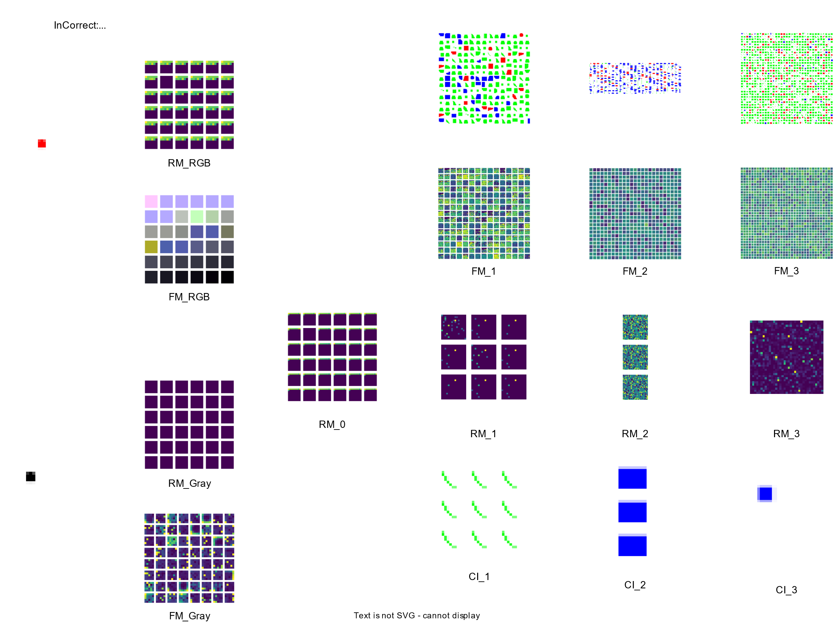

1. **RGB Plan v1 in (64, 64)**:

SOMNetwork(

(RGB_preprocess): Sequential(

(0): RGB_Conv2d(weight shape=torch.Size([36, 3]), kernel size=(5, 5))

(1): cReLU(bias = 0.4)

)

(GRAY_preprocess): Sequential(

(0): RBF_Conv2d(weight shape=torch.Size([64, 1, 5, 5]), kernel size=(5, 5))

(1): cReLU(bias=0.4)

)

(layer1): Sequential(

(0): SFM(filter=(5, 5), alpha=0.9)

)

(layer2): Sequential(

(0): RBF_Conv2d(weight shape=torch.Size([225, 1, 10, 10]), kernel size=(10, 10))

(1): cReLU(bias=0.1)

(2): SFM(filter=(2, 2), alpha=0.9)

(3): RBF_Conv2d(weight shape=torch.Size([625, 1, 15, 15]), kernel size=(15, 15))

(4): cReLU(bias=0.01)

(5): SFM(filter=(1, 3), alpha=0.9)

(6): RBF_Conv2d(weight shape=torch.Size([1225, 1, 25, 25]), kernel size=(25, 25))

(7): cReLU(bias=0.01)

(8): SFM(filter=(3, 1), alpha=0.8999999761581421)

(9): RBF_Conv2d(weight shape=torch.Size([2025, 1, 35, 35]), kernel size=(35, 35))

(10): cReLU(bias= 0.0100)

(fc1): Sequential(

(0): Linear(in_features=2025, out_features=15, bias=True)

)

)

每層的output shape:

Input shape = [-1, 3, 64, 64]

----------------------------------------------------------------

Layer (type) Output Shape Param #

================================================================

RGB_Conv2d-1 [-1, 36, 30, 30] 0

cReLU-2 [-1, 36, 30, 30] 1

RBF_Conv2d-3 [-1, 64, 30, 30] 1,600

cReLU-4 [-1, 64, 30, 30] 1

SFM-5 [-1, 1, 10, 10] 0

RBF_Conv2d-6 [-1, 225, 1, 1] 22,500

cReLU-7 [-1, 225, 1, 1] 1

SFM-8 [-1, 1, 15, 15] 0

RBF_Conv2d-9 [-1, 625, 1, 1] 140,625

cReLU-10 [-1, 625, 1, 1] 1

SFM-11 [-1, 1, 25, 25] 0

RBF_Conv2d-12 [-1, 1225, 1, 1] 765,625

cReLU-13 [-1, 1225, 1, 1] 1

SFM-14 [-1, 1, 35, 35] 0

RBF_Conv2d-15 [-1, 2025, 1, 1] 2,480,625

cReLU-16 [-1, 2025, 1, 1] 1

Linear-17 [-1, 15] 30,390

================================================================

架構圖同RGB Plan v1 in (28, 28)